## TASK 1:

### Service 1: Health

URL: <http://localhost:8080/api/v1/health>

Method: GET

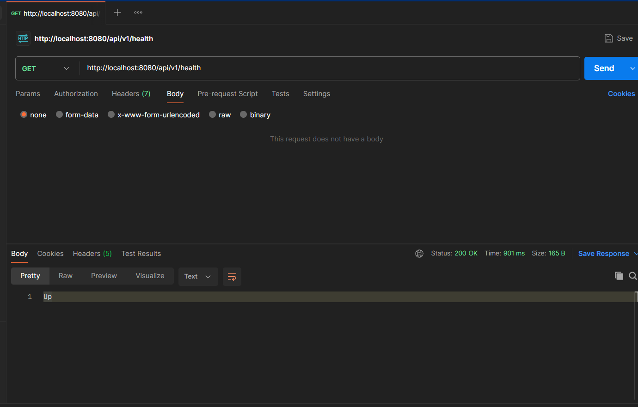

### 

### 

### 

### Service 2:

URL: <http://localhost:8081/api/v1/greeting>

Method: GET

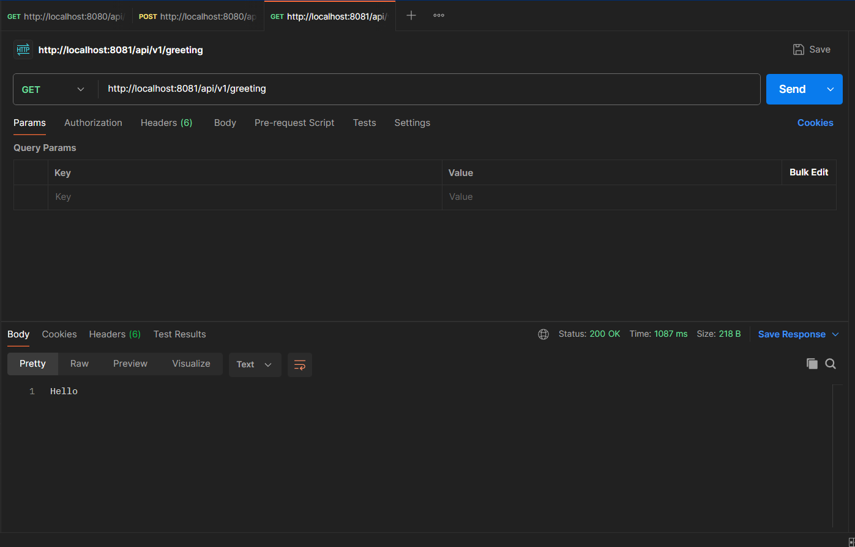

### 

### 

### 

### 

### Service 3:

URL: <http://localhost:8083/api/v1/concat>

Method: POST

Header: Content-Type: application/json

Body: {"Name": "John", "Surname": "Doe"}

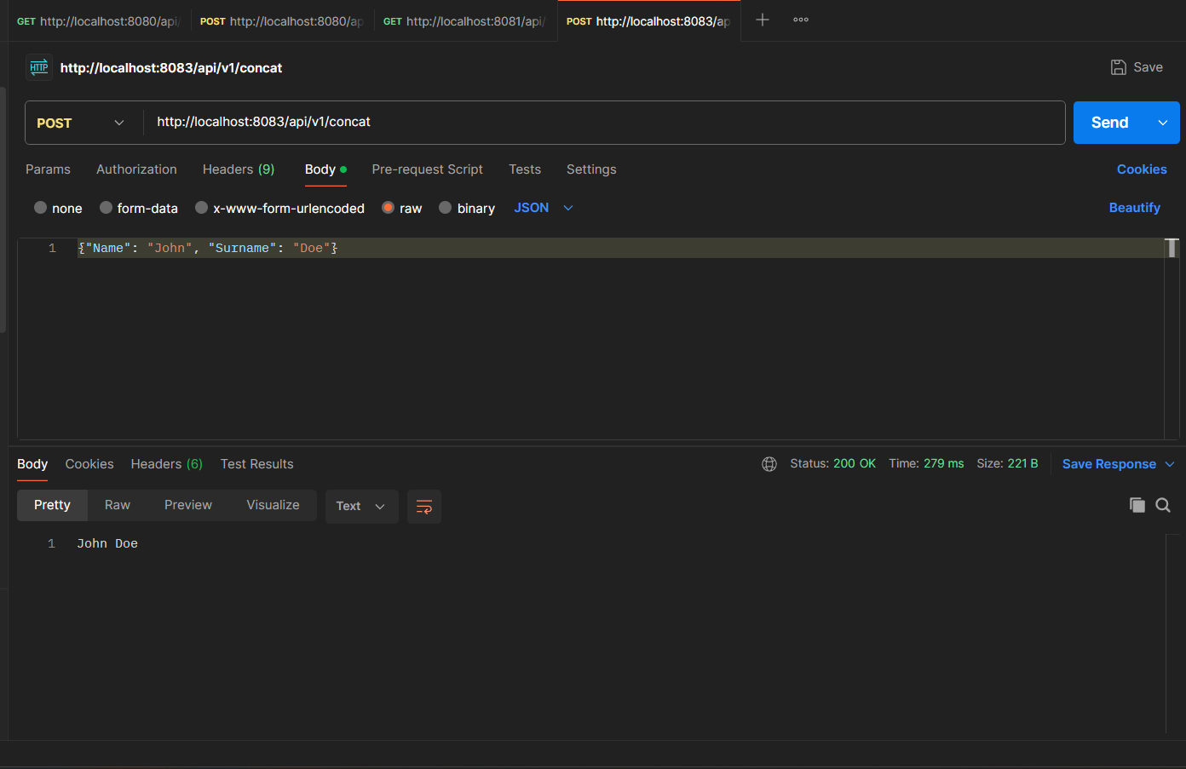

### 

### 

### Service 1: Orchestrate

URL:<http://localhost:8080/api/v1/orchestrate>

Method:POST

Header: Content-Type: application/json , X-Trace-Id: test-123

Body: {"Name": "John", "Surname": "Doe"}

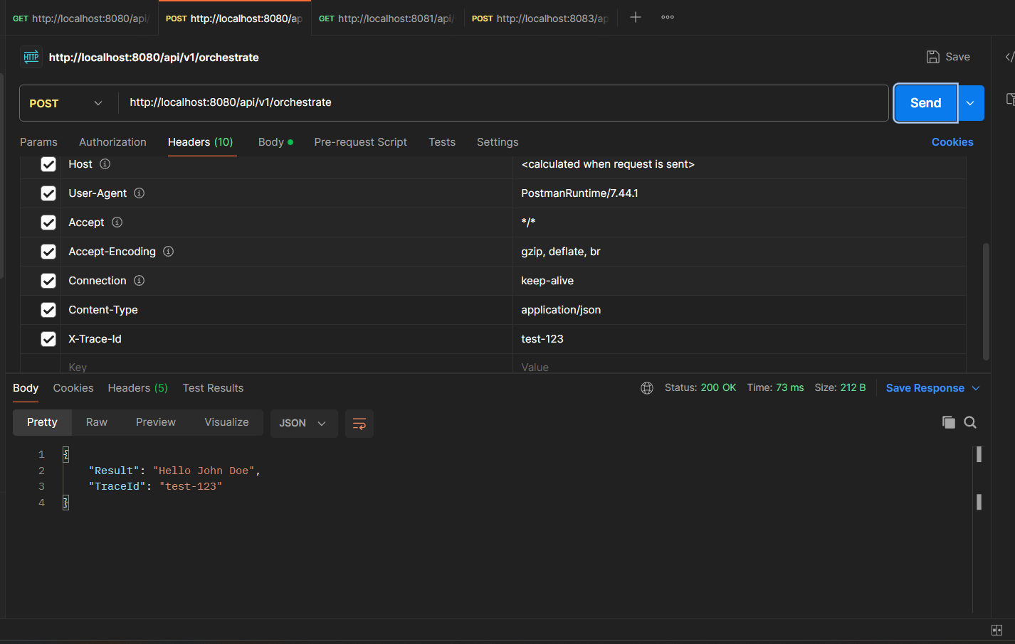

### 

### 

### 

### 

### Service 1: Orchestrate ***//invalid***

URL:<http://localhost:8080/api/v1/orchestrate>

Method:POST

Header: Content-Type: application/json , X-Trace-Id: test-123

Body: {"Name": "John", "Surname": "Doe" ***//invalid***

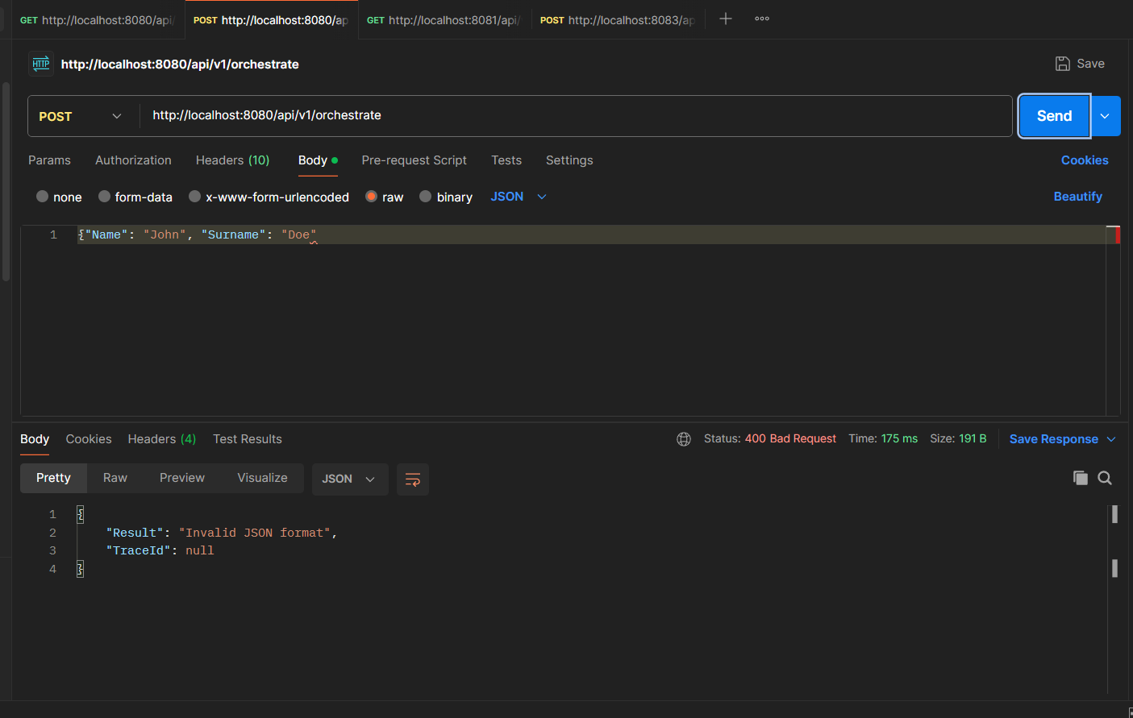

## 

## TASK 2:

### Populate data:

URL: <http://localhost:8085/api/v1/character-classes/populate>

Method: POST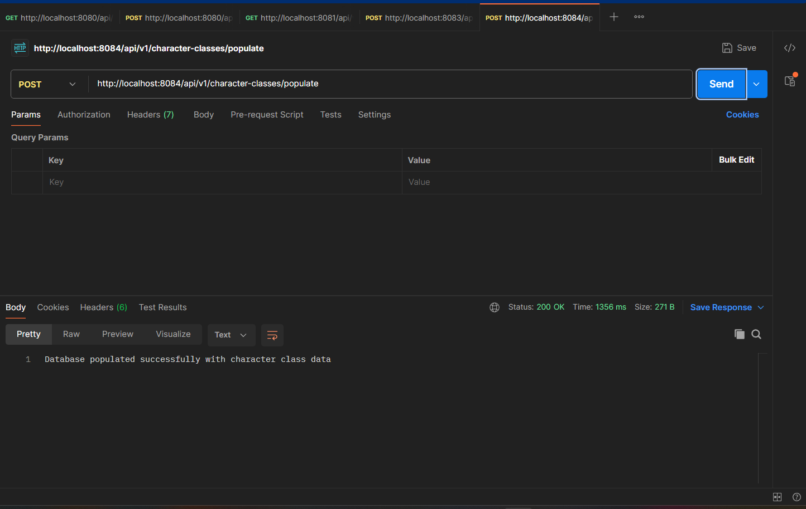

### 

### 

### 

### Nested Data:

URL: <http://localhost:8085/api/v1/character-classes/nested>

Method: GET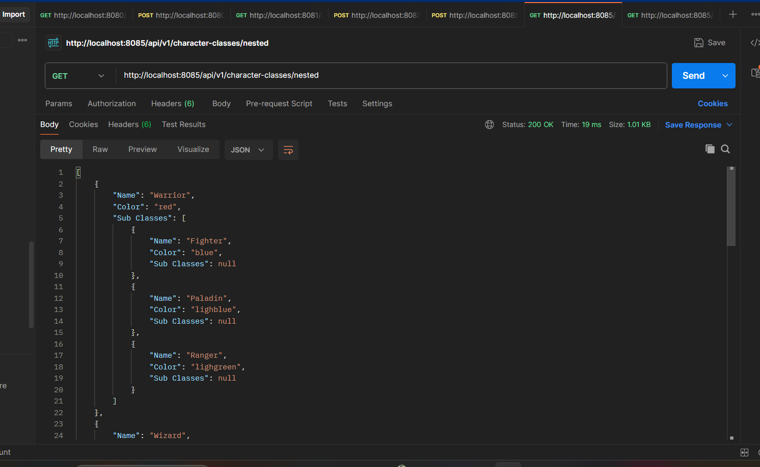

### 

### 

### 

### 

### 

### Get by ID:

URL:<http://localhost:8085/api/v1/character-classes/5>

Method:GET

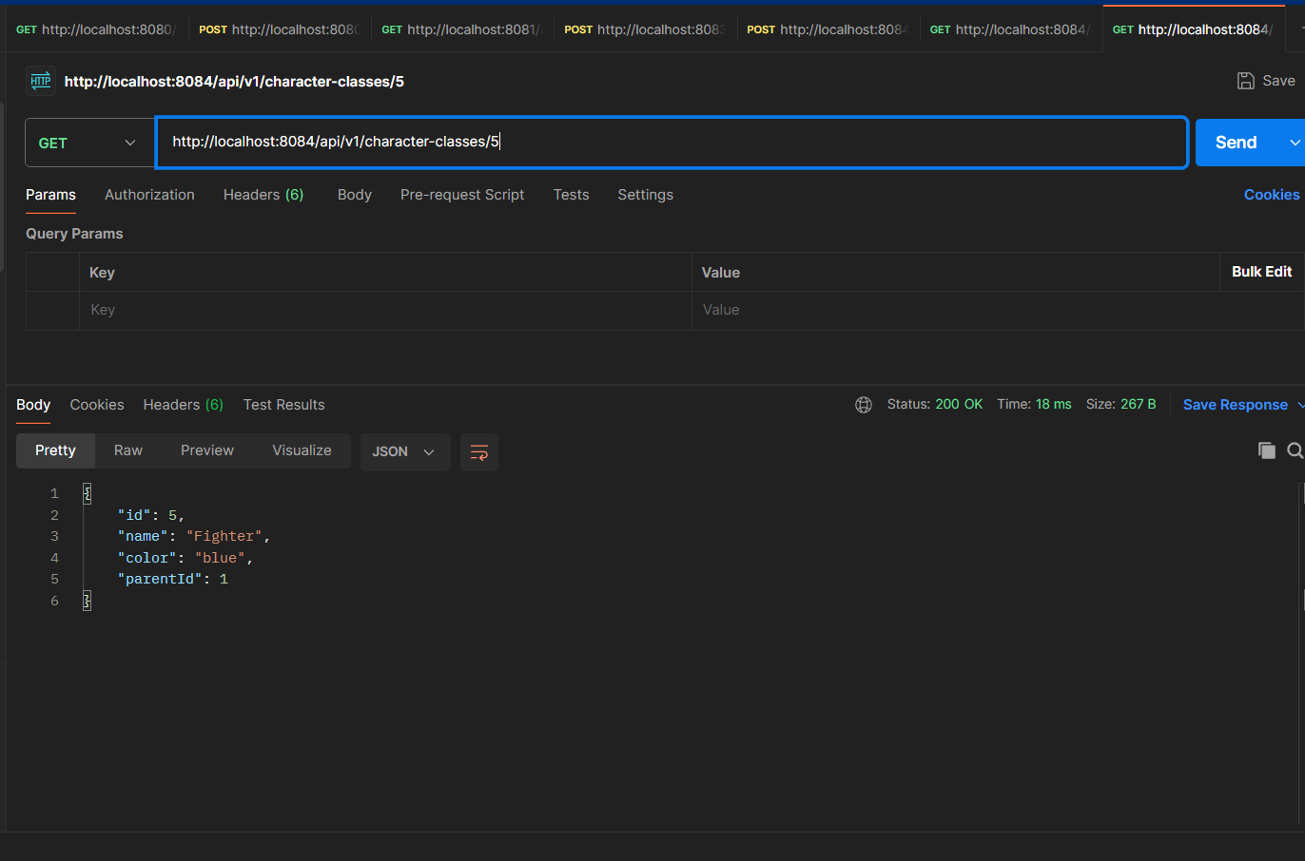

### @LogMethodParam for get by ID:

2025-08-22 15:58:15.420 INFO [service4-database,traceId=3dead5c7-daa1-4735-966c-3240e2d6eda6] 34044 --- [nio-8085-exec-6] c.e.s.aspect.LogMethodParamAspect : Method CharacterClassController.getCharacterClassById called with parameters: [5]

2025-08-22 15:58:15.420 INFO [service4-database,traceId=3dead5c7-daa1-4735-966c-3240e2d6eda6] 34044 --- [nio-8085-exec-6] c.e.s.aspect.LogMethodParamAspect : Method CharacterClassService.getCharacterClassById called with parameters: [5]